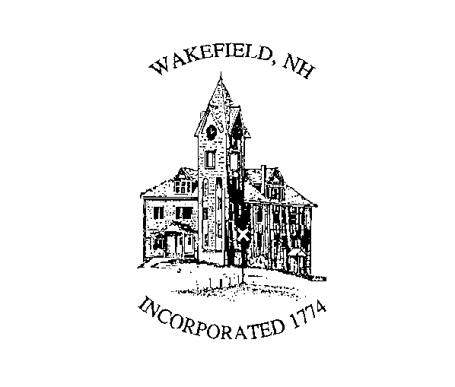Town of Wakefield, New Hampshire

CEMETERY TRUSTEES
2 High Street, Sanbornville, New Hampshire 03872
(603) 522-620503872

CERTIFICATE OF RIGHT TO INTER

KNOW ALL MEN BY THESE PRESENTS, that the TOWN OF Wakefield, a New
Hampshire municipal corporation, with its main place of business at 2 High St. Sanbornville, County of Carroll, State of New Hampshire, by and through its CEMETERY TRUSTEES (herein GRANTORS), for consideration paid, grants to _____________________________________________________________ with mailing address _________________________________(GRANTEES), a Right to Inter on certain property located in Stonehedge or Lovell Lake Cemetery, Wakefield, County of Carroll, State of New Hampshire, said Right to Inter is further described as follows:

A Right to Inter remains in:
Area ____ section___ block___ plot(s)____of the designated Cemetery in said Town in accordance with the Town of Wakefield Cemetery Regulations and Laws of the State of New Hampshire, both as amended.
The above named individual has the sole right to designate the person or persons who may be interred in said plot and to change that designation at any time in the future. The initial designation, if any, is “Appendix A” herein attached. If there is no designation, then by default these persons include the above named individual, his/her mate at the time of his/her death, and his/her children, subject to the capacity of the plot and the rules of the cemetery.

Consideration Received Right to Inter: Eight hundred dollars ($800.00) per plot.

The above named individual(s) shall resell or relinquish this right only to the Town of Wakefield. Upon request at the time of resale or relinquishment, the original Right to Inter fee, not including General Care income, and recording fee, shall be refunded in accordance with the Town of Wakefield Cemetery Regulations and Laws of the State of New Hampshire, both as amended.

General Care funds shall be placed on deposit with the Wakefield Trustees of Trust Funds, the income from which may be spent for reasonable and practical care including raking, mowing and seeding of the herein specified plot(s) as well as the entire cemetery including all plots, unsold areas of the cemetery, and such areas as lawn, roads, and shrubs and trees which have been established by the cemetery. General Care funds shall not be used for the maintenance, repair, or replacement of any memorial, tomb, or mausoleum erected or placed upon a plot, nor the performing of any special or unusual work on the plot(s) or in the cemetery.

In the instance where this plot is found by the Cemetery Trustees to meet the Forfeiture conditions outlined in RSA 289:18, as amended, the Trustees may declare the plot forfeited and may resell the plot. Any notice of Forfeiture shall be recorded in the Carroll Registry of Deeds.

Executed this _____ day of _____________, 20____.

David Tibbetts Jackie Keating

_____________________________ _____________________________
Name Name
Town of Wakefield Town of Wakefield
Cemetery Trustee Cemetery Trustee

Philip Twombley

_____________________________
Name
Town of Wakefield
Cemetery Trustee

STATE OF NEW HAMPSHIRE
COUNTY OF Carroll
On this the _____ day of ________________, 20____, before me, the
undersigned officer, personally appeared a majority of the elected members of the Wakefield, New Hampshire Cemetery Trustees, known to me (or satisfactorily proven) to be the persons whose names are subscribed to the within instrument and acknowledged that they executed the same for the purposes therein contained. In witness whereof, I hereunto set my hand and official seal.

_________________________________
Notary Public/Justice of the Peace
My Commission Expires:____________

In accordance with the Town of Wakefield Cemetery Regulations, the following individuals are authorized to be interred within the specified plot(s).
In the instance that all allowed spaces are not designated, subsequent designations may be made and the Trustees shall allow additional interments in accordance with applicable Regulations and State Statutes.

Interment Designations:

Plot #____: ___________________________________________________
Name /Address
Plot #____: ___________________________________________________

Plot #____: ___________________________________________________

The undersigned hereby agrees to be bound by the terms of this agreement and the Cemetery Ordinance and Regulations, as amended.

Executed this _____ day of _____________, 20__.

______________________________
PURCHASER’S NAME
STATE OF NEW HAMPSHIRE
COUNTY OF Carroll

On this the _____ day of ________________, 20____, before me, the
undersigned officer, personally appeared __________________________, known to me (or satisfactorily proven) to be the person whose name is subscribed to the within instrument and acknowledged that he/she executed the same for the purposes therein contained. In witness whereof, I hereunto set my hand and official seal.

________________________________
Notary Public/Justice of the Peace
My Commission Expires:_____________

Revised: January 1, 2022

