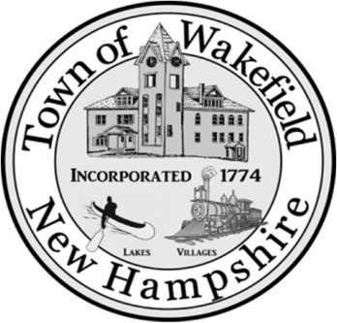
TOWN OF WAKEFIELD, NEW HAMPSHIRE
CONSER CONSERVATION COMMISSION

NOTICE and AGENDA
Monday, July 11th, 2022
7:00 P.M.
Town Hall Conference Room
ZOOM NUMBERS: Meeting ID: 846 4652 6755
Passcode: 977982

- Call to Order
- Introduction of Board Members
- Public comment
- Review/ acceptance of previous meeting minutes for June 27th, 2022.
- New Board Business
  - Review applications, approvals and financials.
  - UMCP update
  - Chuck Robbins presentation

- Old Board Business
- Public Comment
- Set Next Meeting Date and Time, July 25th, 2022 7:00 P.M.
- Adjournment

